- Introduction:

1.1 Purpose:
This SDD presents a detailed design overview of the Legal AI Platform. It describes, among other aspects, the system architecture, modules, components, data design, and mechanisms of interaction. This document will serve as a reference for developers, supervisors, and evaluators in understanding how the system is structured and implemented.

1.2 Scope:
The Legal AI Platform is an online platform which brings together lawyers and their clients using artificial intelligence and communication tools. The platform offers legal advice by artificial intelligence, finding and consulting lawyers, live chatting, and administrative monitoring.
The platform is meant to increase access to lawyers in an efficient, safe, and convenient way.

1.3 Project Background:
This is especially true concerning legal services, which tend to be time-consuming, cost-prohibitive, and complicated for common people. This is besides people not having any legal literacy and finding it difficult to identify the right lawyer. With advancements in artificial intelligence and web development, it has become feasible to automatically provide initial legal advice and connect people with a lawyer.

1.4 Motivation:
The motivation for this project is the need for an upgrade in the legal consultation process, making it less reliant on visits and allowing for immediate legal help. The purpose of this system is time efficiency, transparency, and maintaining confidentiality during legal consultations that are accessible to the public.

1.5 Project Objectives:
- For AI legal advice through machine learning
- To match lawyers with clients based on specialization
- Facilitate secure communication through end-to-end encryption
- To manage users and system activities through admin panel
- To maintain data privacy and system integrity

- Design Methodology and Software Process Model
2.1 Design Methodology:
The system follows a modular and object-oriented design methodology. Each module is designed independently to ensure scalability, maintainability, and reusability. User-centered design principles are applied to ensure ease of use.

2.2 Design Patterns
- Creational Pattern: Factory pattern is used for user creation (Client, Lawyer, Admin)
- Structural Pattern: MVC (Model-View-Controller) is used to separate business logic from UI
- Behavioral Pattern: Observer pattern is used for real-time chat notifications
These patterns improve flexibility, scalability, and system organization.

2.3 Software Process Model:
The Agile software development model is adopted. Agile allows continuous feedback, incremental development, and flexibility in handling changing requirements throughout the development lifecycle.

- System Overview:
3.1 Architectural Design:
The system follows a Client–Server Architecture with cloud-based deployment. The frontend communicates with backend services through secure APIs, while the database and AI modules operate on the server side.

  - Process Flow:
- User registers and logs into the system
- Client interacts with AI chatbot for legal guidance
- Client searches for lawyers by specialization
- Consultation request is sent to a lawyer
- Lawyer accepts or rejects the request
- Secure live chat is initiated upon acceptance
- Admin monitors system activities and logs

- Project Architecture
4.1 Web Module:
4.1.1 Functions:
- User registration and login
- AI chatbot interaction
- Lawyer search and filtering
- Consultation request management
- Secure live chat interface
UI is designed using UX-based methodologies with tools like Figma or Canva.
4.1.2 Architecture:
The web module follows MVC architecture:
Model: Database and business logic
View: User interfaces
Controller: Request handling and system flow
4.2 Database Module
Justification:
A relational database is used to ensure data consistency and integrity.
Database Type:
MySQL
Major Tables:
Users
Lawyers
Clients
Consultations
Messages
System Logs
4.3 Administration Module:
The admin module allows administrators to:
Manage users (Client, Lawyer)
Monitor chat and system logs
Handle reports and system issues
Ensure policy compliance
4.4 Data Dictionary:
UserID = Unique user identifier
Role = Client, Lawyer, Admin
Specialization = Lawyer expertise area
MessageID = Chat message identifier
Timestamp = Date and time of action

5. System Analysis & Design Overview

5.1 Class Diagrams:

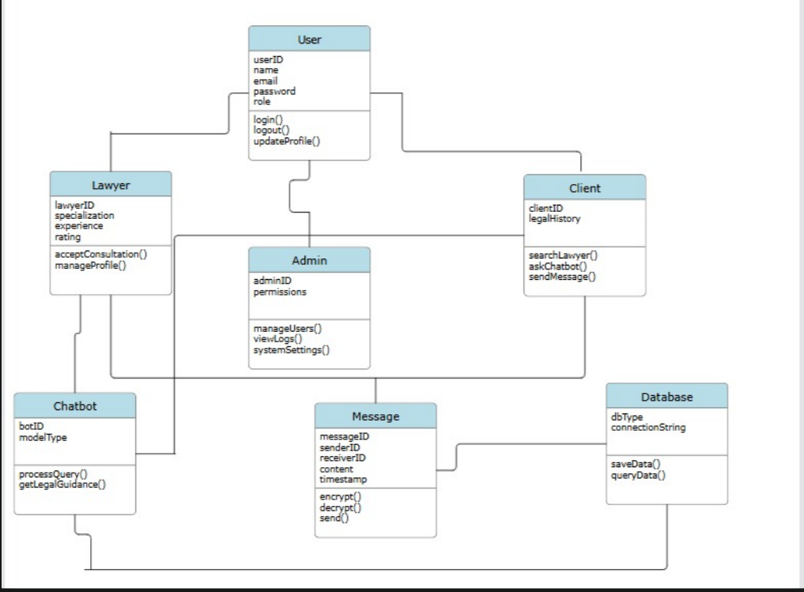

5.2 System Sequence Diagrams:

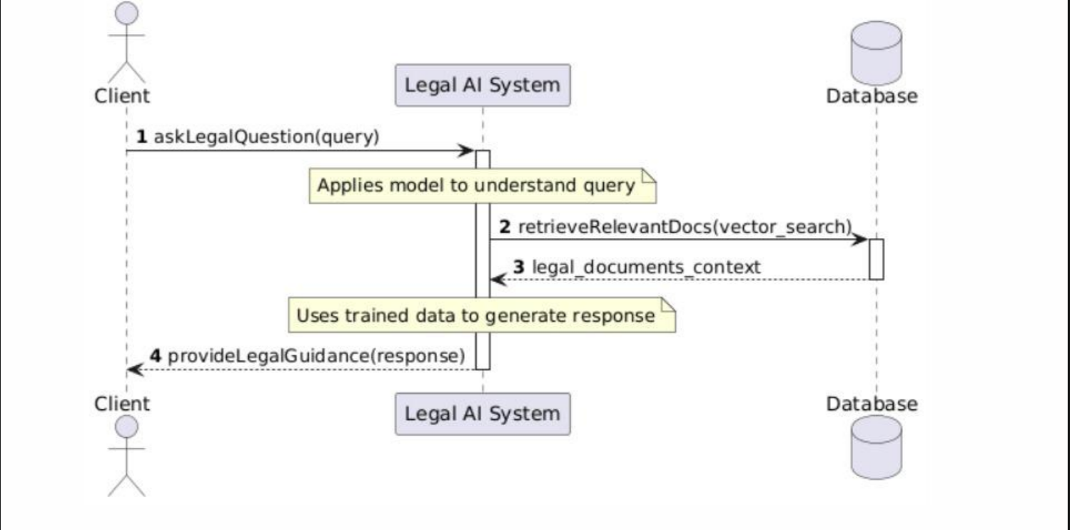

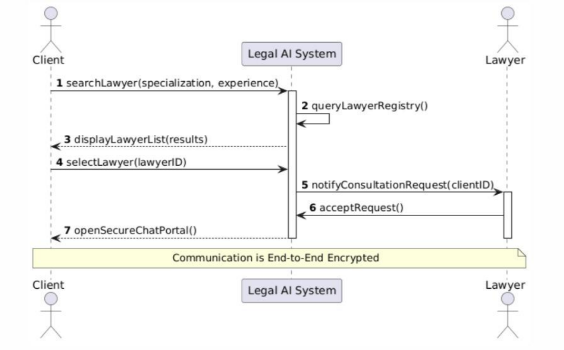

5.3 State Transition Diagram:
